Neuadd Goffa Harlech
22 Hydref 2026 ar 7yn
Mae Cyngor Cymuned Harlech yn gwahodd aelodau o’r cyhoedd i gyfarfod cyhoeddus er mwyn rhannu eu cynlluniau parthed safle y Pwll Nofio a Caeau Chwarae George V.

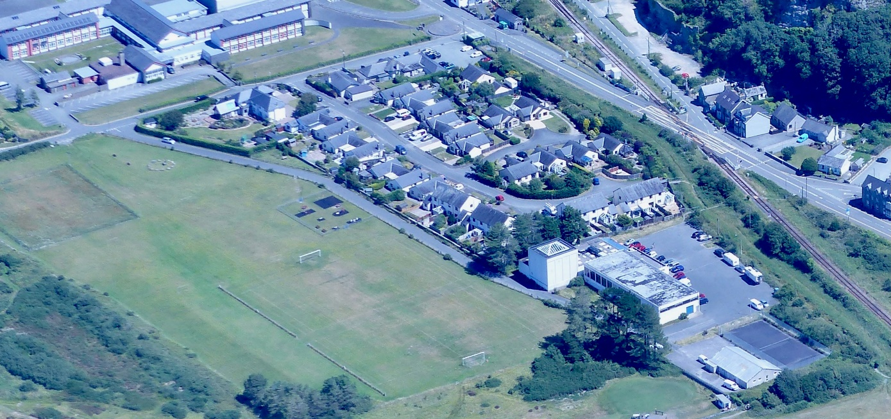

Harlech Community Council invites members of the community of Harlech to a public meeting to share developments to date for the Swimming Pool site and plans for the development of the George Vth Playing Fields at the:
Neuadd Goffa - 22nd October at 7 pm

